|  |  |
| --- | --- |
| **WC Logo.emf** | **Staff Report for Administrative Subdivision Approval**  *Weber County Planning Division* |
|  | |

****Synopsis****

****Application Information****

**Application Request:** Consideration and action on an administrative application for final approval of the Silver Town Subdivision, a one lot subdivision with alternative access by a flag lot access.

**Type of Decision: Administrative**

**Agenda Date: Wednesday, December 14, 2016**

**Applicant:** Eric Jensen, Owner; Robert Cvitkovich Jr, Agent

**File Number:** UVS 112216 & AE 1016

****Property Information****

**Approximate Address:** 3644 East 3300 North, Eden, UT 83410

**Project Area:** 4.316 acres

**Zoning:** Agriculture Valley (AV-3) Zone

**Existing Land Use:** Vacant

**Proposed Land Use:** Residential

**Parcel ID: 22-023-0140**

**Township, Range, Section:** T7N, R1E, Section 29

****Adjacent Land Use****

**North:** Agriculture **South:** Residential

**East:** Residential **West:** Vacant Residential

****Staff Information****

**Report Presenter:** Steve Burton

sburton@co.weber.ut.us

801-399-8766

**Report Reviewer:** RK

Applicable Ordinances

* Weber County Land Use Code Title 104 (Zones) Chapter 6 (AV-3 Zone)
* Weber County Land Use Code Title 106 (Subdivisions)
* Weber County Land Use Code Title 108 Chapter 7 (Flag lot access strip, private right-of-way, and access easement standards)
* Weber County Land Use Code Title 108 Chapter 7 (Flag lots)

Background and Summary

Eric Jensen is requesting approval of the Silver Town Subdivision, a one lot subdivision of 4.316 acres, considered a flag lot, located at approximately 3644 East 3300 North, Eden, in the AV-3 Zone. The applicant is also requesting administrative approval to use the flag lot access strip as the primary access for Lot 1. The proposed subdivision has access from 3300 North where the flag lot access strip exists to the east of the residence located at 3586 East 3300 North. This residence appears to use the flag lot access strip as its primary access from 3300 North.

The flag lot access strip is 29.63 feet wide and 248.73 feet long and will have a fire truck hammerhead with a length of 339.42 feet that will extend to the north, past the access strip and onto Lot 1 (see Exhibit A).

Culinary water will be provided by a private well and wastewater will be controlled by an individual septic system. Electrical and gas utilities will be installed within the PUE boundaries. Prior to Silver Town Subdivision being finalized and recorded, all review agency requirements must be addressed and completed.

The proposed subdivision and lot configuration are in conformance with the applicable zoning and subdivision requirements as required in the Uniform Land Use Code of Weber County (LUC). The following is a brief synopsis of the review criteria and conformance with the LUC.

Analysis

General Plan: The General Plan for Ogden Valley is intended to preserve private property rights while also preserving the rural characteristics of the Valley. Both requests are in conformance with the General Plan.

*Zoning*: The subject property is located in the Agricultural Valley (AV-3) Zone. The applicant has stated in the application that the flag lot will be used to access a future Single-family dwelling. Single-family dwellings are a permitted use in the AV-3 Zone.

*Lot area, frontage/width and yard regulations*: In the LUC §104-6-6, the AV-3 zone requires a minimum lot area of 3 acres and a minimum lot width of 150’. The proposed subdivision is a one lot subdivision that fronts a county road identified as 3300 North. Lot 1 does maintain adequate lot area. The access strip will need to meet the flag lot design standards outlined in LUC 108-7-29.

*Design standards.*

*a. The flag lot access strip, private right-of-way, or access easement shall be designed and built to a standard approved by the county engineer. The improved road surface does not require hard-surface paving, i.e., concrete or asphalt, but the improvements shall meet the following standards.*

*b. The flag lot access strip shall have a minimum width of 20 feet and a maximum width of 30 feet. A private right-of-way or access easement shall have a minimum width of 16 feet and a maximum width of 50 feet. The private right-of-way and access easement width standards may be modified by the Weber Fire District in conjunction with the county engineer on a case-by-case basis.*

*c. The improved travel surface of the flag lot access strip, private right-of-way, or access easement shall be a minimum of 12 feet wide if the access serves fewer than five dwellings, and a minimum of 20 feet wide if the access serves five or more dwellings.*

*d. The improved road surface of the flag lot access strip, private right-of-way, or access easement shall be capable of supporting a minimum weight of 75,000 pounds.*

*e. A turnout measuring at least ten feet by 40 feet shall be provided adjacent to the traveled surface of the a flag lot access strip, private right-of-way, or access easement (private access) if the private access is greater than 200 feet in length. The turnout shall be located at the approximate midpoint of the private access if its length is between 200 and 800 feet. If the private access length is greater than 800 feet, turnouts shall be provided at least every 400 feet thereafter. These standards may be modified by the Weber Fire District in conjunction with the county engineer on a case-by-case basis.*

*f. The flag lot access strip, private right-of-way, or access easement shall have a maximum grade of ten percent. This standard may be modified by the Weber Fire District in conjunction with the county engineer on a case-by-case basis; however, the maximum grade shall not exceed 15 percent.*

*g. The flag lot access strip, private right-of-way, or access easement shall have a minimum vertical clearance of 14.5 feet.*

*h. No buildings, structures, or parking areas are allowed within the flag lot access strip, private right-of-way, or access easement.*

*i. New bridges, including decking and culverts shall be capable of supporting a minimum weight of 75,000 pounds. For existing bridges, a current certified engineer statement of load bearing capabilities must be submitted to the county engineer and the Weber Fire District for review.*

*j. The flag lot access strip, private right-of-way, or access easement shall have a minimum inside travel-way radius of 26 feet, outside travel-way radius of 45 feet, and outside clear zone radius of 50 feet on all curves, particularly switchbacks. The width of the access may need to be increased to accommodate these standards.*

*k. Water and sewer lines located within the flag lot access strip, private right-of-way, or access easement require written notification from the agencies providing such services.*

A condition of approval has been included to ensure the flag lot design standards are met.

As part of the subdivision process, the proposal has been reviewed for compliance with the current subdivision ordinance in LUC 106 chapter 1, and the AV-3 zone standards in LUC 104-6-6. The proposed subdivision will not create any new public streets. The proposal meets the criteria for “Small Subdivisions”, as defined in LUC 101-7, and can be administratively approved per LUC 106-1-5(b)(1).

*Culinary water and sanitary sewage disposal:* Feasibility letters have been provided for the culinary water and the sanitary sewer for the proposed subdivision. The culinary water for the proposed subdivision will be provided by a private well. The sanitary sewage disposal will be an individual waste water treatment system. All review agency requirements must be addressed and completed prior to this subdivision being recorded.

*Review Agencies*: To date, the proposed subdivision has not been reviewed by the Engineering Division, Weber Fire District, or the Surveying Division. The Planning Division has completed a review of the plat in relation to the safety standards in LUC 108-7-29 2(a).

*“The lot address shall be displayed in a prominently visible location at the street entrance to the flag lot access strip, private right-of-way, or access easement”.*

A condition of approval has been included as part of staff’s recommendation for approval. The applicant will need to submit a revised plat with all agencies conditions met prior to recording the final Mylar

*Additional Design Standards*: The proposed subdivision does not require the realignment of or the creation of a new street system. With the exception of the recommended conditions identified in this staff report, additional standards and requirements are unnecessary at this time.

*Tax Clearance*: There are no outstanding tax payments related to this parcel.

*Public Notice*: A notice has been mailed not less than seven calendar days before final approval to all property owners of record within 500 feet of the subject property regarding the proposed small subdivision per noticing requirements outlined in LUC §106-1-6.

Staff Recommendations

Staff recommends final approval of the Silver Town Subdivision, a one lot subdivision with access by a flag lot access strip. This recommendation is subject to all review agency requirements and based on the following conditions:

1. The lot address shall be displayed in a prominently visible location at the street entrance to the flag lot access strip, private right-of-way, or access easement.
2. Prior to recording the final Mylar, all conditions required by Weber County reviewing agencies must be met.
3. Prior to recording the final Mylar, the flag lot design standards must be met.

This recommendation is based on the following findings:

1. The proposed subdivision conforms to the Ogden Valley General Plan.
2. With the recommended conditions, the proposed subdivision complies with applicable county ordinances.
3. The proposed subdivision will not be detrimental to public health, safety, or welfare.
4. The proposed subdivision will not deteriorate the environment of the general area so as to negatively impact surrounding properties and uses.

Administrative Approval

Administrative final approval of the Silver Town Subdivision and alternative access by a flag lot access is hereby granted based upon its compliance with the Weber County Land Use Code. This approval is subject to the requirements of applicable review agencies and the conditions of approval listed in this staff report.

Date of Administrative Approval: Wednesday, December 14, 2016.

________________________________________

Rick Grover

Weber County Planning Director

Exhibits

1. Silver Town Subdivision Application
2. Plat Map
3. Silver Town Flag Lot Alternative Access Application
4. Feasibility letters

Area Map 1

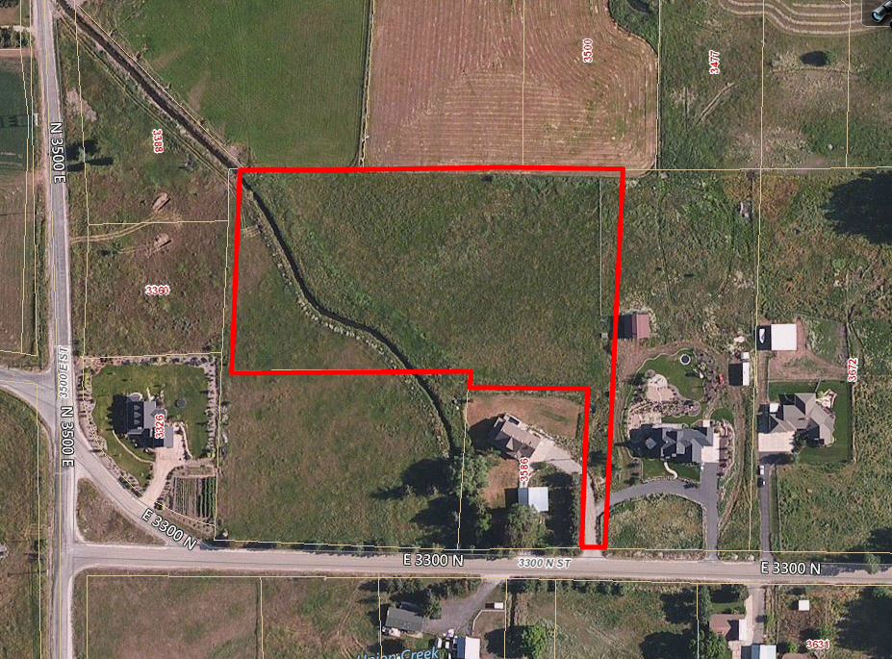

Subject Property

Area Map 2

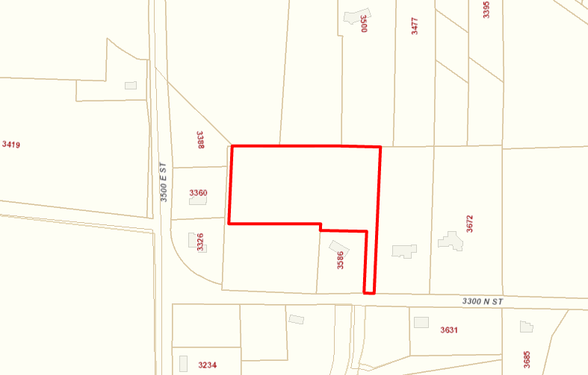

Subject Property