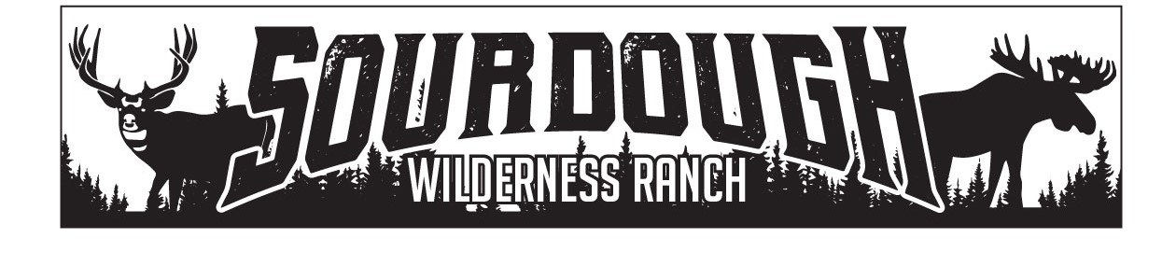
1150 N. Hwy 89 Suite B
Harrisville, UT 84404
801-773-3348
Sourdoughranch@gmail.com

Weber County
2380 Washington Blvd., Suite 240
Ogden, Utah 84401

RE: Jason Grover
RE: Elk Horn 61 Shed
April 11, 2022
Jason Grover has been approved to place a shed up to 100sq ft in size on Elk Horn Lot #61 by the board of trustees of Sourdough Wilderness Ranch.

Sincerely,

Shawna Lee

Shawna Lee
Office Manager
Board Secretary/Treasurer

