

**RYAN ARBON, SHERIFF**

AARON PERRY, CHIEF DEPUTY

BRANDON ROUNDY, CHIEF DEPUTY

March 11, 2021

To Whom It May Concern,

The Weber County Sheriff’s Office will be providing Public Safety assistance for the GOAL Foundation’s WRC 30K race being conducted in Eden on April 24, 2021.

We will provide traffic control and public safety assistance as deemed necessary to help provide for a safe event while minimizing disruptions to the businesses and citizens within the area.

Deputies will be provided as needed at the discretion of the Sheriff’s Office.

Feel free to contact me anytime if you have any questions.

Lt. Brent Butler

Weber County Sheriff’s Office

(801)721-3952

bbutler@co.weber.ut.us

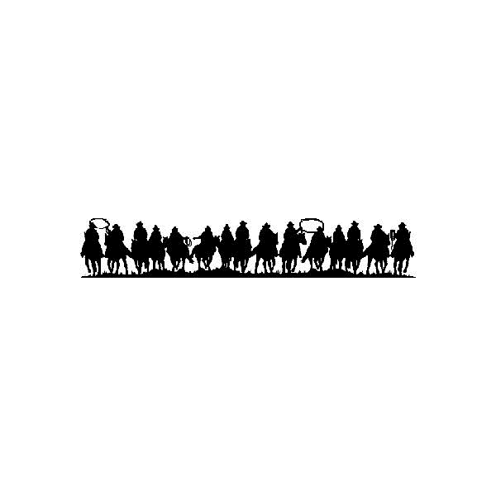

801-778-6600 Enforcement / 801-778-6700 Corrections / 1400 South Depot Drive, Ogden Utah 84404 [www.webercountyutah.gov/sheriﬀ](http://www.webercountyutah.org/sheri%EF%AC%80)