Weber County
Rezone Agreement

PARTIES: The parties to this Agreement are Horseshoe LLC and Sunnyfield LLC (“the Petitioner”) and Weber County Corporation (“the County”).

EFFECTIVE DATE: The effective date of this Agreement will be the date upon which the Weber County Commission (“the Commission”) signs the Agreement.

RECITALS: Whereas, the Petitioner has previously rezoned a portion of parcel number 22-047-0040 located at 2145 North 5500 East Eden, Ut from the Agricultural Valley-3 (“AV-3”) Zone to the Commercial Valley-2 (“CV-2”) Zone for the general purpose of constructing retail and professional space; and

WHEREAS, the County seeks to promote health, safety, welfare, convenience, and economic prosperity of the residents of the County through the establishment and administration of zoning regulations concerning the use and development of land in the unincorporated area of the County as a means of implementing the adopted General Plan; and

WHEREAS, the Petitioner has requested to rezone the remaining portion of parcel number 22-047-0040, a portion of parcel number 22-047-0052 and a portion of parcel number 22-047-0053, as shown in Exhibit “A” attached hereto and incorporated herein by this reference (“the Property”) from AV-3 to CV-2; and

WHEREAS, the Petitioner has historically produced an attractive and quality product that will stand the test of time and will support the visual desire of the community and meet the requirements of the Ogden Valley General Plan and the Weber County Land Use Code; and

WHEREAS, any future commercial buildings will be reviewed and analyzed during the Design Review Process with the County; and

WHEREAS, the Petitioner and the County have a good working relationship in so much that the County has utilized the Petitioner’s design team for elements in the proposed “Old Town Eden” Small Area Plan.

WHEREAS, the Petitioner desires to continue to work with the County to complete the proposed “Old Town Eden” Small Area Plan prior to designing the new street front commercial buildings in order to conform to the new standards that will be required as part of the adopted Small Area Plan; and

NOW THEREFORE, for good and valuable consideration, the receipt of which is hereby acknowledged and accepted, both parties mutually agree as follows:

- The County will zone the Property shown in Exhibit “A” from the AV-3 Zone to the CV-2 Zone for the purpose of allowing the Petitioner to utilize the existing structures on the Property for uses allowed in the CV-2 Zone, excluding those Automotive intensive uses as detailed in Exhibit “B”.

- Until such time that the “Old Town Eden” Small Area Plan is adopted, the Petitioner will be subject to the guidelines as outlined in the Ogden Valley General Plan specifically the Old West/Mining architectural style elements.

- However, the County and the Petitioner agree that if the “Old Town Eden” Small Area Plan is not adopted within twenty four months of this Agreement, number 2 of this Agreement will become null and void and the Petitioner will be able to move forward with design, approval and construction process on the Property subject to current CV-2 land use code.

- CV-2 Excluded Uses as detailed in Exhibit “B” will expire 10 years from the signing of this agreement and upon expiration of the agreement the Property will retain its CV-2 zoning.

Documents Attached:
Exhibit “A” (Commercial Valley-2 (CV-2) Zone Boundary)
Exhibit “B” (CV-2 Excluded Uses)
Exhibit “C” (Legal Description)

Approved by the parties herein undersigned this ______ day of _________________, 20____.

______________________________________
Horseshoe LLC

______________________________________
Sunnyfield LLC

On this _____ day of _____________, 20___ personally appeared before me, Shawn Clegg, Manager of Horseshoe LLC and Sunnyfield LLC, both Limited Liability Companies which executed the foregoing instrument and that said instrument was signed on behalf of both said Limited Liability Companies, and acknowledged to me that both Limited Liability Companies executed the same.
STATE OF )
) ss
COUNTY OF )
_________________________________________
Notary Public

Approved as to form:

__________________________________ ______________________
Weber County Attorney Date

Approved:

___________________________________ _______________________
Chair, Weber County Commission Date

Attest:

___________________________________ ________________________
Weber County Clerk/Auditor Date
Exhibit “A”

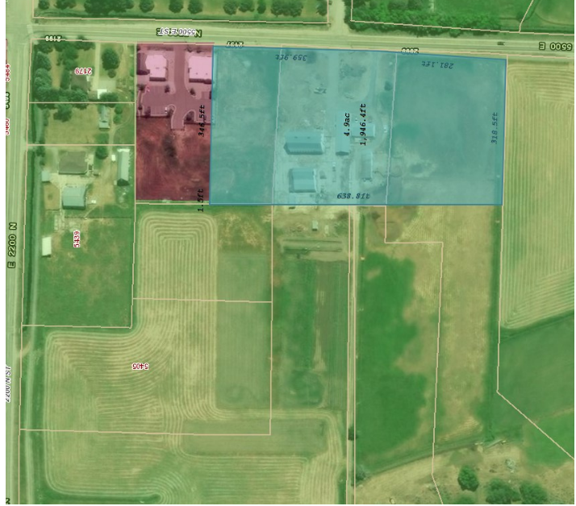

Exhibit “B”
CV-2 Excluded Uses

Excluded uses:
- Automobile repair including paint, body and fender, brake, muffler, upholstery, or transmission work provided it is conducted within an enclosed building
- Automobile, new or used sales/service
- Boat sales and service
- Boat and personal watercraft rentals as an accessory use to boat sales and service
- Car rental agency
- Car wash, automatic
- Car wash, manual spray
- Motorcycle and motor scooters sales and service
- Parking lot or garage as a main use
- Recreational vehicle storage
- Restaurant, drive-through
- Service station, automobile excluding body, fender, and upholstery work
- Service station, automobile with 1 bay automatic car wash as an accessory use
- Snowmobile, ATV sales and repair.

Exhibit “C”
Legal Description

