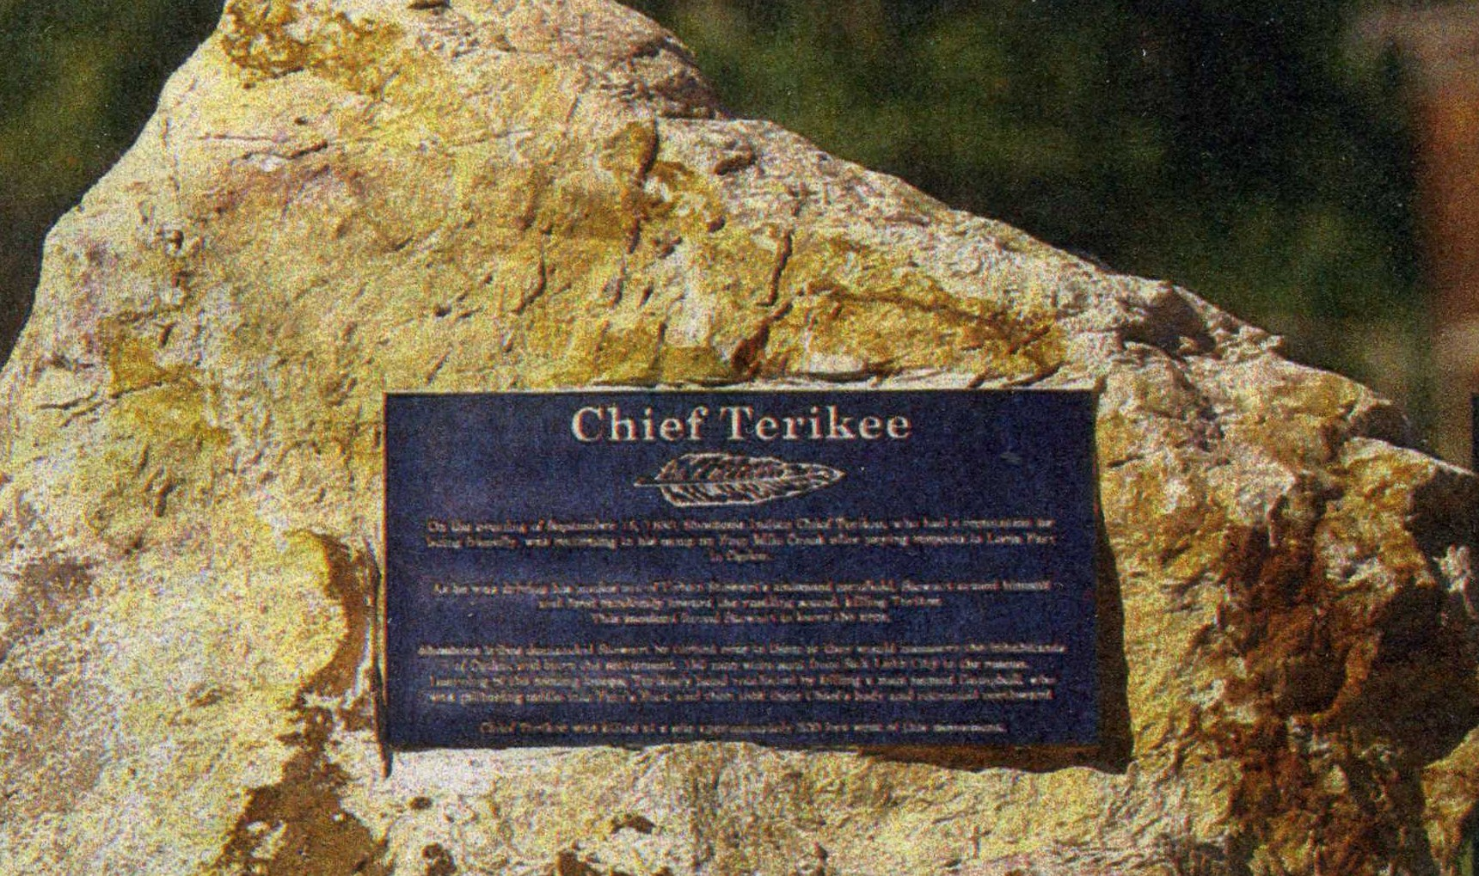

Terakee Village®

In the early nineteenth century, Chief Terikee and the Shoshone people lived along the Weber River near modern day West Weber, Utah. Prior to being settled by pioneers from the eastern United States, this land is where the native people hunted, gathered and farmed for survival.

In the 1850s, members of the Blanch family traveled from Europe to help settle the western frontier in Utah. The family obtained property in West Weber, along the lower Weber River, through the first federal land grants given in the area.

Terakee Village recognizes the spirit of Chief Terikee, the Shoshone people, and the settlers who lived on and preserved this land. We have named this community after Chief Terikee, while adding an “A” in place of the “I” to also reference the Latin word for earth, terra.

Terakee Village is made up of 60 acres and is a sister community to the nearby agri-community development, Terakee Farm. By offering smaller lots and varied dwelling options at Terakee Village, we will provide additional living options for individuals in Weber County who would like to live near, but not in the agro-community, Terakee Farm. Terakee Village will also feature an assisted senior living facility, allowing entire families to live in close proximity to one another regardless of what stage of life they are in.

In an effort to accommodate individuals from all stages of life, Terakee Village will feature smaller lot sizes, townhomes and amenities, such as a market and an emergency care center. A reflection park and ample open green spaces will also be available to residents, while allowing them to live in close proximity to the organic farm and open walking trails that are open to the community at Terakee Farm.

Open green community spaces, convenient amenities and a variety of home styles and lot sizes will contribute to bringing diversity to the area, and promote a connection between neighbors and members of the surrounding area. With all of these offerings, Terakee Village will also continue to promote the vision that we have for Terakee Farm of bridging the gap between West Weber’s agrarian past and the conveniences of modern lifestyles that people seek today.

