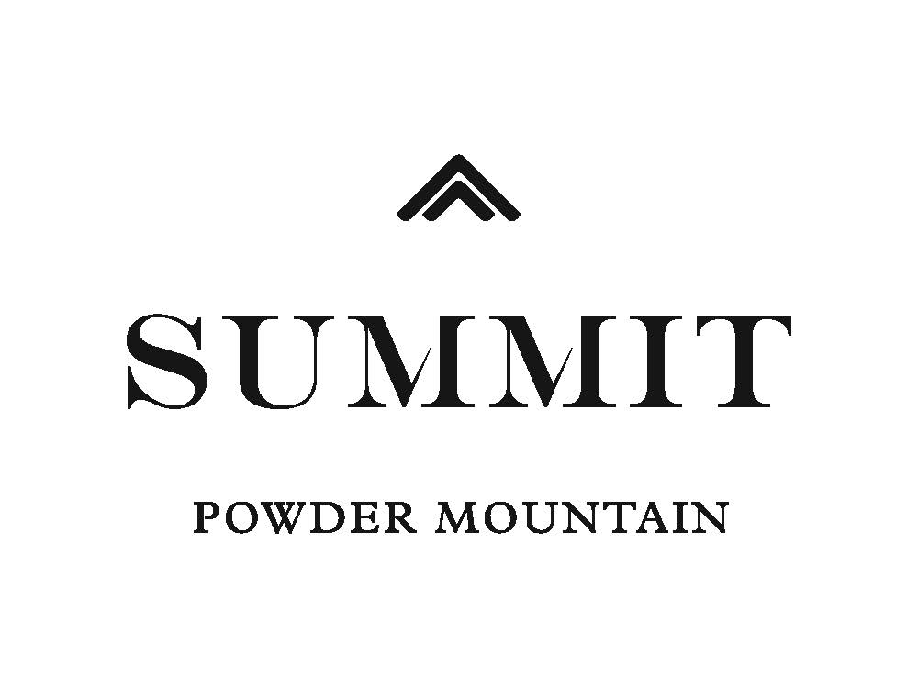

Planning Commission
2380 Washington BLVD #240
Ogden, UT 84405

To Whom It May Concern:

We are requesting a reduction in the required number of parking spaces for the liquor store from twenty to two for following reasons:

- The liquor store is substantially smaller than other liquor stores. We estimated the size of the Utah State Liquor Store on Patterson in Ogden to be approximately 8,300 square feet using Google Earth. Outpost Spirits will be approximately 500 square feet or 1/16 the size of the Patterson store. Dividing the 20 space requirement by 16 results in a parking space requirement of 1.25 spaces.
- The small size of the liquor store will reduce the number of choices within the store and reduce browsing time. It is likely that the amount of time spent inside the store by any particular customer will be far less on average than at other stores.
- The proposed liquor store is a Type 1 liquor store pursuant to the DABC’s regulations. A Type 1 license is “a package agency under contract which is operated in conjunction with a resort environment (e.g., hotel, ski lodge, summer recreation area)”. It is accessory to the resort environment. Many of the customers will come from nearby and may be present on the property to visit other businesses that are located on the property.
- The uses on the property (retail store, restaurant, liquor store, grill) have all been on the property at the same time during the history of the building.
- The parcel was previously owned by one owner and has a single parking lot that spans three parcels. The total parking in the parking lot is in excess of 110. All of these spaces are within 500 feet of the building as required by Sec. 108-8-7 of the Weber County Code.
- The building is serviced by the Utah State Transit Authority during the ski months and liquor store patrons may arrive at the building via public transportation.
- The restaurant, which is the largest user of the parking lot on the parcel, does the majority of its business in the evening. The golf course that utilizes the parking lot (and is on the adjacent parcel) is a seasonal business and does the majority of its business during the daylight hours.
- The uses are at different times
- Applicant proposes to reserve two parking spaces for the exclusive use of liquor store patrons.
- Applicant is willing to add at least three additional parking spaces in the area marked (2) on the site plan.
- We recently partnered and introduced Uber, a taxi like service, to the Ogden Valley Area. This service is in addition to UTA’s service and provides patrons with a means of transportation during and after UTA’s scheduled service hours. As the Ogden Valley grows, Summit Powder Mountain is dedicated to continue support and partner with more Transportation companies.

The parking requirements for other uses on the property should be reduced for the following reasons:

- During the winter months our buildings are serviced by the Utah State Transit Authority; thus, patrons of the restaurant and ski rental area can commute from Ogden to our amenities via public transportation. This reduces the amount of parking stalls needed.
- According to Section 108-8-4 of the Land Use Code, a designated Real Estate Office requires one space per two employees plus four spaces for client use. Our Real Estate office is temporarily located in Eden, but the Village and areas we are promoting are located on top of Powder Mountain. Consequently, all of our sales and meetings with clients are held on mountain. Thus, We feel the four spaces for client use should not apply.

Sincerely,

Kimber Brady
Operations Specialist
Summit Powder Mountain

