Code Enforcement
Weber County Planning Division
Synopsis
Basic Information |  |  | Violation
Type of Violation: Business in an out building, Refused an Inspection, No building permits. |  |  | 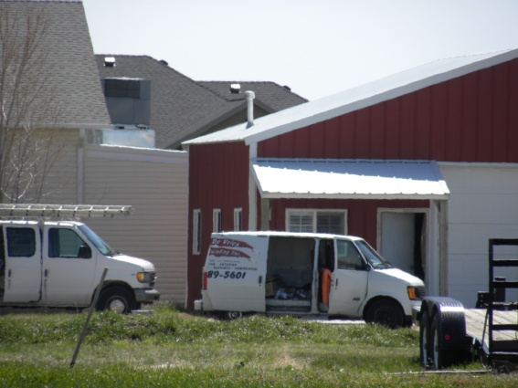
Date: Friday, May 17, 2013
Applicant Mrs. Georgia Nicholas
File Number: 17052013
Land Information
Approximate Address: 3757 North 3900 West
Zoning: Agricultural A-2
Existing Land Use: Residential/Agricultural
Parcel Identification Number: 19-108-0002
Township, Range, Section: Township 7 North, Range 2 West, Section 21.
Information
Mrs. Nicholas,
It is a violation of the Unincorporated Weber County Ordinance chapter 34 Home Occupation, to have your home business located outside your home, your home occupation shall not occupy more than 400 square feet or 25 percent, whichever is less, of the ground floor area of the home. The home occupation shall not use any space in an attached or unattached garage, accessory building, yard or any space on the premises outside of the dwelling.
You have also refused an onsite inspection of your property, any improvements such as electrical, mechanical or change in occupancy of a garage, shed or barn, should be accompanied by the relevant building and land use permits.

Please contact me at 801-399-8762, to resolve this matter within fourteen (14) days of the date of this notice or this letter will be sent to the Weber County’s Attorney’s Office for further action and criminal review.
Nothing in this notice should be seen as prohibiting the County from taking immediate action in this matter to protect public health, safety, and the general welfare.

I will be happy to assist you with any questions you may have regarding this matter or about the Weber County Zoning Ordinance.

ENC:- The Unincorporated Weber County Code of Ordinances Title 104 Zones, Chapter 7, Agricultural A-2 Zone.
The Unincorporated Weber County Code of Ordinance s Title 108 Home Occupation, Chapter 13, Home Occupation.
Title 14 Business Licensing

Iris Hennon, Code Enforcement Officer
Weber County Planning Division

