2233 E 5950 N Liberty, Utah Variance of up to 20 ft on rear setback
We are planning to build our dream home at 2233 E 5950 N in Liberty, Utah. As outdoor enthusiasts, the primary reason we chose this property was because of its proximity to North Fork Park and the surrounding natural beauty. We are requesting a variance of up to 20 ft to the minimum rear setback—from 30 feet to 10 feet—to allow us to design a home that harmonizes with the land while preserving the existing trees and natural landscape of FV-3 as much as possible. Listed below are the five criteria for granting a variance with our rationale as to how we meet each criteria:
- Literal enforcement of the ordinance would cause an unreasonable hardship for the applicant that is not necessary to carry out the general purpose of the Land Use Code.
  - In determining whether or not enforcement of the land use ordinance would cause unreasonable hardship, the appeal authority may not find an unreasonable hardship unless the alleged hardship is located on or associated with the property for which the variance is sought, and comes from circumstances peculiar to the property, not from conditions that are general to the neighborhood.
  - In determining whether or not enforcement of the land use ordinance would cause unreasonable hardship, the appeal authority may not find an unreasonable hardship if the hardship is self-imposed or economic.

- Although the property is 1.1 acres in total (~240 ft long by 210 ft wide), less than half of it is buildable due to slope and terrain constraints
  - The front half of the lot adjacent to the street (NE) contains > 30 degree slopes, descending 15-20 ft to an intermittent drainage stream/easement
  - The buildable area of the lot is adjacent to the rear (SW) property line, and is roughly 120 ft long and 200 ft wide before the sharp downward grades
  - We are able to manage side setback ordinances with the current terrain
  - However, applying a 30 ft rear setback, and up to 15 ft of clearance from the sensitive grade, leaves only about 75 ft in length left to use
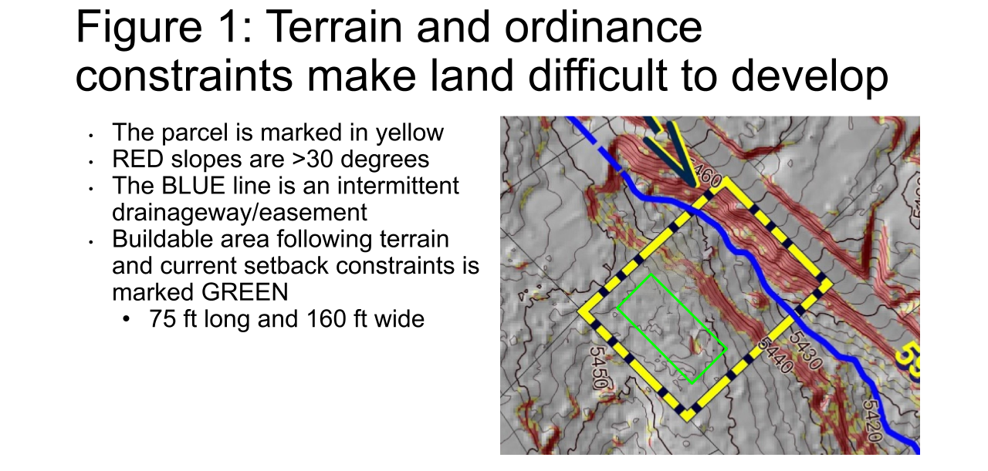
- LUC§ 104-16, states: “The purpose of the Forest Valley Zone, FV-3 is to provide area for residential development in a forest setting at a low density, as well as to protect as much as possible the naturalistic environment of the development.”
  - Adding a variance will grant us more flexibility to work with the land and preserve the principles of FV-3, by allowing us to rotate the home and protect more forest and natural grade

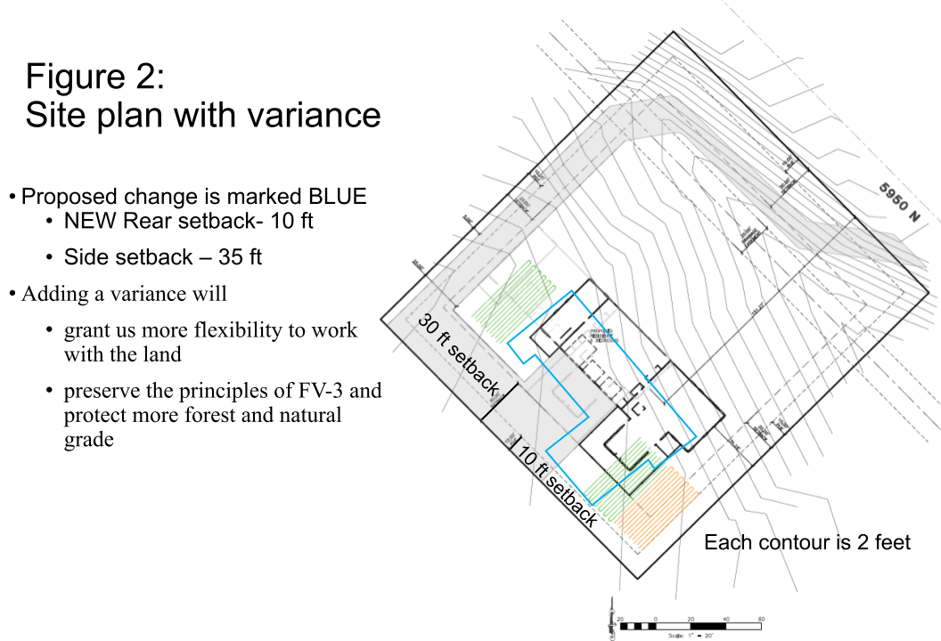

- There are special circumstances attached to the property that do not generally apply to other properties in the same zone.
  - In determining whether or not there are special circumstances attached to the property, the appeal authority may find that special circumstances exist only if the special circumstances relate to the hardship complained of, and deprive the property of privileges granted to other properties in the same zone.

- Our ~1.1 acre property is uniquely and significantly affected by both multiple steep slopes and the drainage easement, significantly reducing our usable building area.
  - The >30 degree slopes at the front and middle of the property and the drainage easement take up more than half of the total area of the lot.
  - Many of the other lots in FV-3 are 3 acres or more, and the areas with steep grades do not occupy such a large portion of total land and are at the rear of those properties, resulting in larger practical buildable areas
  - Reducing the rear setback would allow our property to have a buildable area comparable to that of other properties in the same zone.
- Granting the variance is essential to the enjoyment of a substantial property right possessed by other property in the same zone.
- Being able to build a house on the flattest portion of land is something other property owners in the area have been able to do. Without an amendment to the rear setback, it will be very difficult to develop this parcel
- The drainage easement and grades in the front of the lot still present significant hardship for access
- In addition, while nearby parcels have been developed, our parcel has remained undeveloped for 20-30 years, likely due to the difficulty in development
- The variance will not substantially affect the general plan and will not be contrary to the public interest.

- The majority of the house will be 30 feet or more from the rear property line. Only a small portion of the actual house is in need of the 20 foot variance in setback. Approximately 700 square feet of construction would exist in the variance - of which the majority (~500 sq ft) consists of the porch to protect from the sun, while less than ~200 sq ft consists of the great room.
- The lot against the rear property line (SW) and the lot that is diagonal/South of ours is owned by the same property owners. Their home is located on the kiddy corner lot.
- With a 10 ft setback, we will have enough usable land to be able to rotate the house slightly away from this neighbor’s house, giving them more privacy. Additionally, this allows for the distance between this house and ours to remain the same, so even with a smaller setback, we are not closer to their primary residence.
- With a 10 ft setback, we will not have to clear a large quantity of trees (an additional ~1500 sq ft of trees).
  - This will give us more privacy to the main street and the Southeast neighbor’s recently constructed park and property.
  - This will allow us to preserve the natural landscape and remote feel of the neighborhood.
Figure 3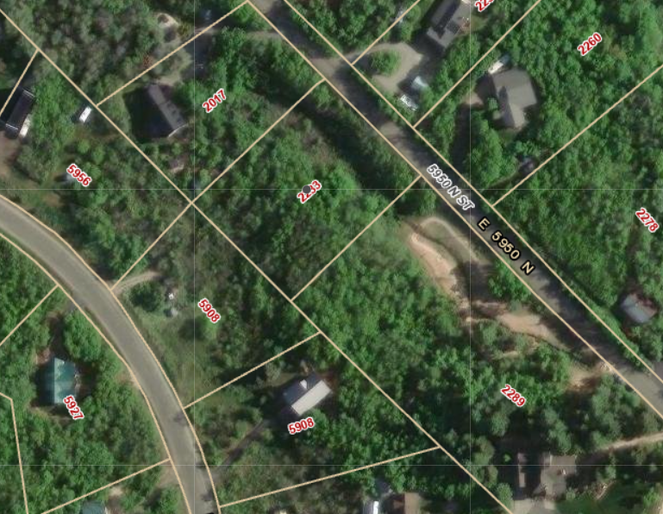

- The spirit of the land use ordinance is observed and substantial justice done.

- Please consider the unique conditions of this lot and allow us to responsibly develop our property in alignment with our property rights and in a way that protects the landscape and keeps the neighborhood intimate.

