Code Enforcement
Weber County Planning Division
Synopsis
Basic Information |  |  | Violation
Type of Violation: 1. Junk, 2, No Conditional Use |  |  | 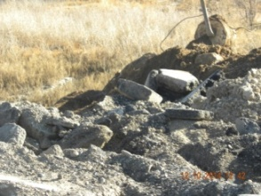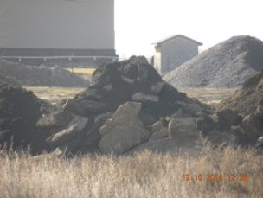
Date: Tuesday, March 17, 2015
Applicant: Brent & Amy Kap
File Number: 17032015
Land Information
Approximate Address: 3637 North 3900 west
Zoning: Agriculture A-2
Existing Land Use: Agriculture/Residential
Parcel Identification Number: 15-027-0103
Information
Dear Mr. Mrs. Kap,

It is a violation of the Unincorporated Weber County Ordinance to allow the collection of garbage, junk, Junk means all discarded metals, scrap metals, iron, glass, paper, wood, building materials, unused or discarded building materials, lumber, accumulations of dirt, gravel, ashes, or fire remains, or any other waste materials upon any property. Unincorporated Weber County Land Use Code Title 30 chapter 5. In order to fill in a natural depression you must first apply for and have a conditional Use before you commence with your project. Land Use Code Title 104 chapter 4-2.

You need to stop and desist with the fill project until you have first obtained a Conditional Use. The used asphalt and concrete and any other waste and discarded material used in the fill will need to be removed. This will need to be removed within fourteen (14) days of the date of this notice, or a written plan submitted for the disposal of said waste to the Planning Division.

If this matter is not resolved within fourteen (14) days of the date of this letter; or a written plan is not in place, this letter will be sent to the Weber County’s Attorney’s Office for further action and criminal review. Nothing in this notice should be seen as prohibiting the County from taking immediate action in this matter to protect public health, safety, and the general welfare.

I will be happy to assist you with any questions you may have regarding this matter or about the Weber County Zoning Ordinance, I can be reached at 1-801-399-8762.

ENC:- Unincorporated Weber County Land Use Code Title 30 Public Offences chapter 5. Land Use Code Title 104 Gravel Zone G chapter 4-2 Conditional Uses.

Iris Hennon, Code Enforcement Officer
Weber County Planning Division

