Code Enforcement
Weber County Planning Division
Synopsis
Basic Information |  |  | Violation
Type of Violation: 1. Unpermitted change of Out Building, 2. Set Back issues with building and corrals. |  |  | 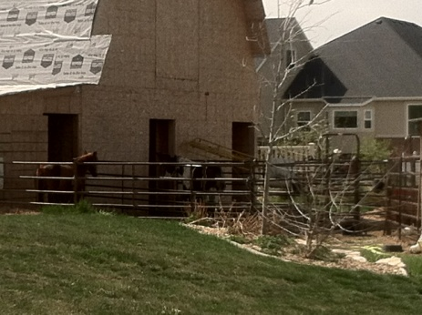
Date: Friday, April 24, 2015
Applicant: Christian Facer
File Number: 2442015
Land Information
Approximate Address: 1668 South Degiorgio Street
Zoning: Agriculture A-1
Existing Land Use: Agriculture/Residential
Parcel Identification Number: 15-219-0010
Information
Dear Mr. Facer,
It has come to our attention you are out of compliance with the Unincorporated Weber County Land Use Code, Title 102 chapter 4-4 Land Use Permit, and Title 104 chapter 3-7.
We appreciate that you may not be aware that there are ordinances in place governing your property; these standards were developed to maintain the safety in your community.
There are issues with your new out building. You have been approved by the appropriate County agencies to commence the building of an outbuilding not to accommodate the housing of animals. On the application you were informed you could not use this structure to house animals and as you have three openings in the back of the building allowing horses to go in and out of the building this constitutes the housing of animals. Your building must be brought into compliance and the openings blocked off, not allowing animals access in to the building, and the corrals must be move from the back of the building.
When obtaining your permit the County is aware that you did discuss with the Planning Division as to what you could and could not do with the building; because the set back requirements could not be met in regards to the housing of animals your permit states not for the housing of animals. Corrals, stables, or any buildings for keeping of animals or fowl must not be located any closer than one hundred (100) feet from a public street and not less than twenty-five (25) feet from any side or rear lot line, and as your new out building and corrals do not meet any of the set back’s as written in the Code the corrals and animals must be removed and relocated with the relevant setbacks.
Title 102-chapter 4-4 Land Use Permit
In order to verify zoning requirements and setbacks for permitted or conditional uses, no structure, including agricultural structures, shall be constructed, changed in use, or altered, as provided or as restricted in the Weber County Zoning Ordinance, until and unless a Land Use Permit is approved and issued by the Planning Director or designee.

Title 104-5-3 (7) Agriculture preferred use.
Corral, stable or building for keeping animals or fowl, provided such structure shall be located not less than 100 feet from a public street and not less than 25 feet from any side or rear lot line.

Please have this matter taken care off within 14 days of the date of this letter or this will be sent to the Weber County’s Attorney’s office for further action and criminal review.
Nothing in this notice should be seen as prohibiting the County from taking immediate action in this matter to protect public health, safety, and the general welfare.

I will be happy to assist you with any questions you may have regarding this matter or about the Weber County Land Use Code. You can contact me at (801-399-8762)

ENC:-Unincorporated Weber County Land Use Code, Title 102.chapter 4-1-7
Title 104, chapter 5-3 (7) Agricultural Zone A-1
Iris Hennon, Code Enforcement Officer
Weber County Planning Commission.

